Module 2 **: Installation and Maintenance of Hardware and Its**

**Answers sheet**

* **Section 1: Multiple choice**

1. **B**  [ Electrostatic discharge can damage sensitive computer components like the motherboard, RAM, and CPU.]
2. **C** [ Thermal paste fills in microscopic gaps between the CPU and the heat sink, ensuring better heat transfer.]
3. **A**  [ A digital multimeter is used to measure voltage, current, and resistance.]
4. **A**  [ The CMOS battery powers the CMOS chip, which stores BIOS settings.]
5. **True** [ When installing a new hard drive, formatting is essential to prepare it for storing data.]
6. **False** [ A POST (Power-On Self-Test) error can indicate a problem with various hardware components, not just the CPU.]
7. **False** [ While it may seem safe, removing a USB flash drive without ejecting it can cause data corruption or loss.]
8. Installing a new graphic card in desktop computer following few steps before you start you should shut down computer after that unplug all of the cables from the back of the computer. **step 1**: remove expansion slot plates **step 2**: open your PCLe Slot after **Step 3**: Install the Graphics card **Step 4**: Secure the Graphics Card , to the expansion slot the chassis with screws. **Step 5** Attach your PSU Connectors **Step 6**: final step in this process is that connect your Monitor and boot the pc install or update derivers.
9. First of all we needs tools for disassembly like Phillips-head screwdriver, thermal paste and anti static wrist strap that it. After that our first step is shut down computer and unplug all cables. Remove the side panel of the case using a screwdrier. Remove the old CPU fan you can see

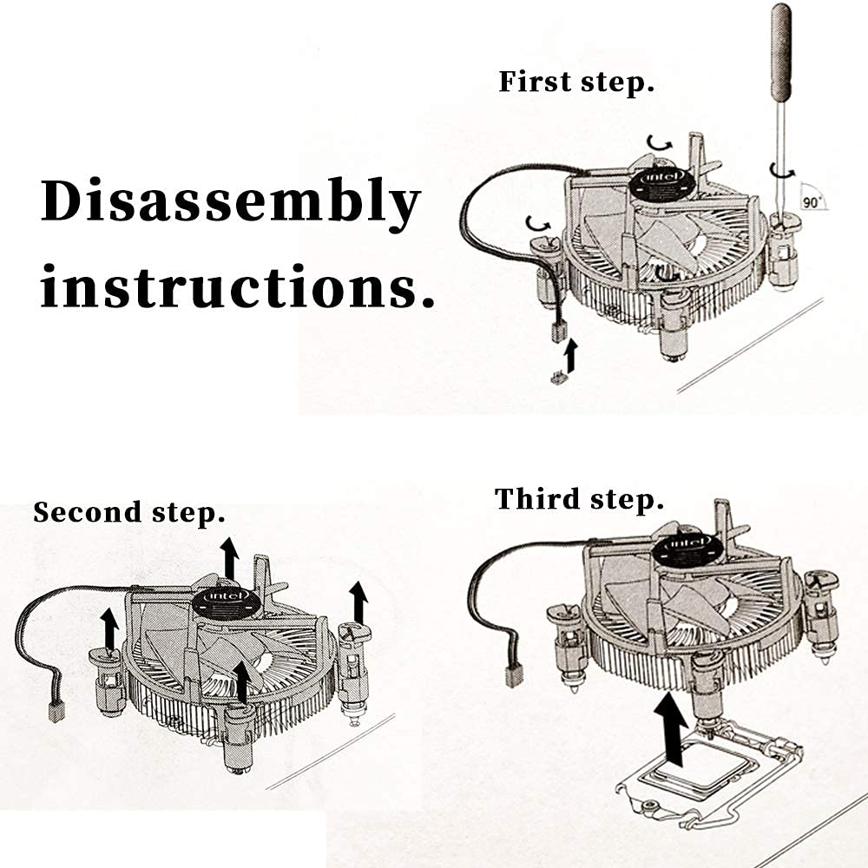

this image in first step how to remove fan from CPU. Unplug the fan cable from the CPU FAN header on the motherboard after that use a screwdriver. You can see in image after remove fan we can unplug that cable and also open that lock which in available in fan. Finally your remove fan you should clean before install new fan. Last but not in the list step is install new CPU fan.

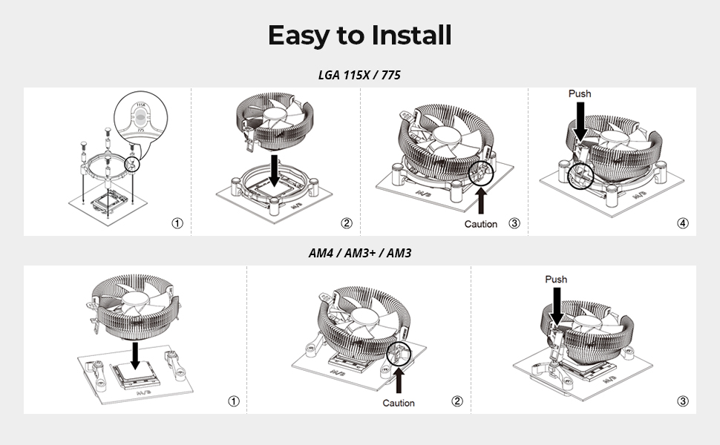

You can see in this image how to install CPU fan before installing make sure the new fan onto the existing heatsink using screws or clips whatever give with fan mostly give a clips by default. Finale step is check all cable and all on position after that reattach the side panel and reconnect power cables. Additionally, power on the computer and press boot key go on bios to chack fan is show or not if not then install.

1. The Importance of Regular Maintenance for Computer Hardware

In today's digital age, computers have become an indispensable part of our daily lives. From simple tasks like browsing the internet to complex operations like data analysis, computers play a vital role in facilitating our work and personal activities. However, like any other machine, computers require regular maintenance to function efficiently and effectively. Neglecting computer hardware maintenance can lead to slow performance, data loss, and even complete system failure. Therefore, it is essential to understand the importance of regular maintenance for computer hardware and perform routine tasks to ensure optimal performance.

Another crucial aspect of regular maintenance is data protection. Hard drives are prone to data corruption and loss, especially if not properly maintained. Tasks like running disk checks, disk defragmentation, and creating backups can help prevent data loss and ensure business continuity. For example, running a disk check can identify and fix errors on the hard drive, preventing data corruption and loss. Similarly, creating regular backups can ensure that critical data is safe in case of system failure or data loss.

Regular maintenance also helps to improve system performance. Over time, computers can become slow and sluggish due to software updates, malware, and temporary files. Tasks like updating operating systems, uninstalling unnecessary software, and deleting temporary files can help improve system performance. For instance, updating the operating system can fix bugs and improve system security, while uninstalling unnecessary software can free up disk space and reduce system load.

In addition to these benefits, regular maintenance can also help extend the lifespan of computer hardware. Replacing worn-out parts, such as batteries and fans, can help extend the life of the computer. Similarly, cleaning the computer's exterior and interior can help prevent damage from dust and moisture. For example, cleaning the keyboard and mouse can prevent damage from spills and dust, while replacing the battery can ensure that the laptop remains functional on the go.

Some common maintenance tasks :-

* Cleaning dust from fans and heat sinks

* Checking for loose connections and inspecting for signs of physical damage

* Running disk checks and creating backups

* Updating operating systems and software

* Uninstalling unnecessary software and deleting temporary files

* Replacing worn-out parts, such as batteries and fans

* Cleaning the computer's exterior and interior

In conclusion, regular maintenance is essential for computer hardware to function efficiently and effectively. Neglecting maintenance tasks can lead to hardware failure, data loss, and system crashes. By performing routine tasks, computer users can prevent hardware failure, protect data, improve system performance, and extend the lifespan of their computers. Therefore, it is crucial to prioritize regular maintenance to ensure optimal performance and longevity of computer hardware.